Name | KHALEEL ABDULLAH KHAN
Class | 7 A1

Purpose:
"Skill Assessment Program - Building Strengths Beyond Academics "
This report shows your child's interests and abilities in different school activities. With your (parents) support and our guidance, these strengths can grow into useful life skills. It helps parents notice early signs of talent and areas where extra care or practice can make a big difference.

Key Insights:
The graph below shows how your child is doing in different areas. It tells us what they like more and where we can help them do even better. Blue represents your child, and red represents the class average.
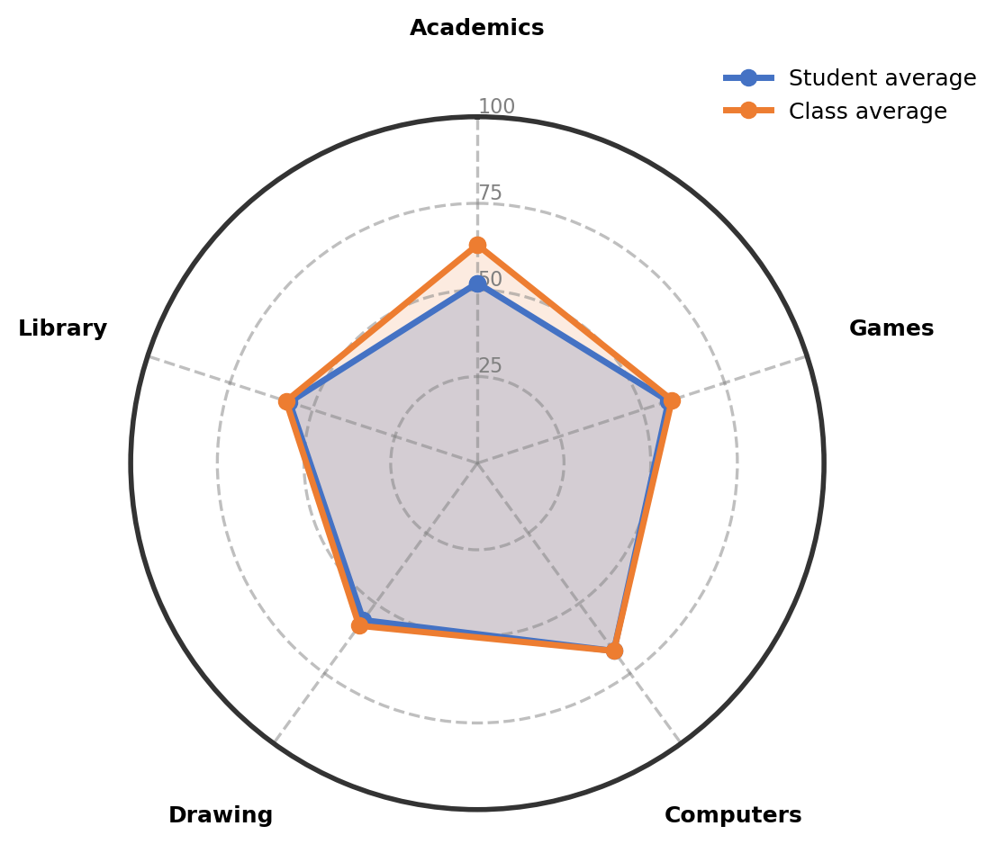

Observations:
The table gives an overview of child's involvement and performance across co-curricular areas.
Interest Area | Engagement (%) | Interest Level | Key Observations
Computers | 67% | Showing Strong Interest | Demonstrates strong interest in computers with basic drawing and typing skills, showing good potential with practice.
Games | 58% | Building Confidence Gradually | Enjoys playing cricket and shuttle, building skills through active participation.
Library | 57% | Building Confidence Gradually | Shows good reading interest and is gradually building confidence in library activities.
Drawing | 56% | Emerging Interest | Shows emerging interest in drawing, particularly enjoying anime-style artwork.
Academics | 52% | Progressing With Guidance | Shows clear interest in English and Mathematics, working well with support.

Recommendations & Growth Opportunities:
Here are some ways to turn your child's interests into long-term strengths:
Strong Interest Area | Potential Careers | Simple Activities to Support
Computers  (67%) | This strong computer interest can lead to exciting technology fields. Exploring software development, game design, digital art creation, or data analysis becomes possible. Building logical thinking and creative problem-solving through computers benefits many future paths. | Enroll in a structured computer class focusing on basic programming or digital drawing to strengthen technical skills
Games  (58%) | This growing interest in games can connect to various sports and physical activity fields. Exploring sports coaching, physical education, sports management, or fitness training becomes possible. Developing teamwork, coordination, and discipline through games benefits overall development. | Join a local cricket or shuttle coaching program to improve specific techniques and build confidence

How Parents Can Help:
1. Weekend Exploration (Computers): Dedicate a weekend afternoon to a fun, structured online tutorial that teaches basic animation or simple game design, connecting it to the interest in computers and drawing.
2. Short Daily Practice (Games): Encourage 15 minutes of cricket or shuttle practice in the evening to maintain the interest in sports and improve hand-eye coordination.
3. Encourage and Talk: Dedicate 10-15 minutes weekly to talk about what excites your child in computers or games and offer your appreciation for their efforts in these activities.

Conclusion:
Your child shows wonderful natural strengths in computers and games, with growing interests in academics and drawing. This is a perfect time for exploration and skill-building without pressure. Each activity helps develop different abilities that will serve well in the future. Continue supporting this balanced growth with patience and encouragement.

Notes:
Parents remarks:
Teachers' remarks:

